Home Page Content for the Obas of Lagos Website

Welcome to the Legacy of Lagos
Discover the extraordinary Legacy of Lagos’s traditional leadership, where history, culture, and royalty converge to define one of Africa’s most iconic cities. Step into the timeless story of the Obas of Lagos – custodians of tradition, architects of progress, and symbols of unity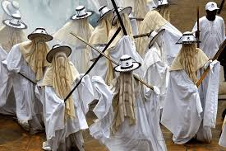.

Preserving the Past, Inspiring the Future
The Obas of Lagos have stood as enduring figures of leadership, from the founding of Lagos in the 17th century to its rise as a global metropolis. Our platform is your gateway to exploring this remarkable lineage and understanding the role of these royal leaders in shaping Lagos's identity and resilience.

What Awaits You

1. Journey Through Royal History
Experience the captivating stories of Lagos’s monarchs, from Ado, the first Oba of Lagos, to the modern leadership of Oba Rilwan Akiolu I. Uncover the milestones, traditions, and legacies that have defined each reign.

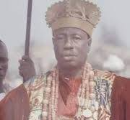

First leaders of Lagos palace(Ado)



Present Oba of Lagos(Oba Akinolu)

2. Cultural Heritage Unveiled
Immerse yourself in the vibrant customs, regalia, and ceremonies of Lagos’s monarchy. Learn how these traditions have kept the city’s spirit alive across generations.
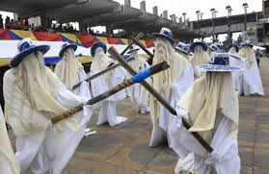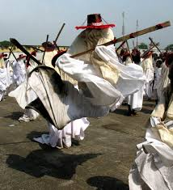

3. Interactive Experiences
Explore an interactive timeline, historical galleries, and rare archival content that bring the legacy of Lagos’s royalty to life.
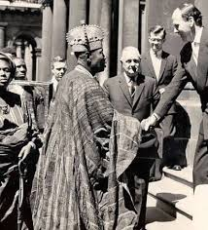

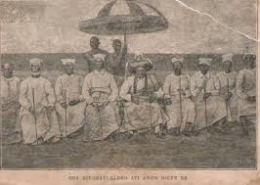

4. Connect with Royalty
Discover how the monarchy continues to inspire unity and progress in modern Lagos, blending traditional values with contemporary significance.

Why This Matters
The Obas of Lagos are more than just traditional leaders; they represent a bridge between the past and the future. By preserving their stories, we honor the resilience and diversity of Lagosians and celebrate the city’s pivotal role in Africa's cultural and economic landscape.

Explore, Learn, Celebrate
Whether you’re a history enthusiast, cultural explorer, or a proud Lagosian, this platform invites you to dive deep into the heart of Lagos’s royal heritage. Let the stories of courage, wisdom, and unity inspire you.

Get Started Today
- 📜 Explore the Timeline: Begin your journey with a detailed exploration of the Obas and their reigns.
- 📷 View Our Gallery: Step back in time through rare photos, artifacts, and memorabilia.
- 💡 Learn More: Dive deeper into the fascinating world of Lagos's monarchy.

Join the Royal Experience
Stay connected with us for updates, new discoveries, and opportunities to participate in preserving Lagos's royal heritage. Sign up and follow us on social media to be part of this exciting journey.
Discover the Majesty. Celebrate the Legacy.

